**Assignment 1**

Due: By midnight on Weds, Sept 18th, via Canvas. Have one person from each group submit one Cohort_Group#_HW1.ipynb (e.g., BA1_Group3_HW1.ipynb) file to the Assignments area of Canvas, which provides the solutions to the below problems. Indicate the full names and student numbers of your team members at the top of the notebook.

**1. Lawsuit Cash Flow Problem**

An individual has successfully sued your company in a lawsuit over a hazardous product. The court’s judgement mandates that you pay this individual the following amounts each year for the next 15 years:

|  |  |  |  |  |  |  |  |  |  |  |  |  |  |  |  |
| --- | --- | --- | --- | --- | --- | --- | --- | --- | --- | --- | --- | --- | --- | --- | --- |
| Year: | 0 | 1 | 2 | 3 | 4 | 5 | 6 | 7 | 8 | 9 | 10 | 11 | 12 | 13 | 14 |
| Amount  (in $1,000s) | 10 | 11 | 12 | 14 | 15 | 17 | 19 | 20 | 22 | 24 | 26 | 29 | 31 | 33 | 36 |

Suppose the following safe investment options are available to you (the company):

|  |  |  |  |  |  |
| --- | --- | --- | --- | --- | --- |
|  |  | Current cost | Yearly return | Years to maturity | Principal repayment at maturity |
| Option 1: | Bond 1 | $980 | $60 | 5 | $1000 |
| Option 2: | Bond 2 | $965 | $65 | 12 | $1000 |
| Option 3: | Savings account | - | 4% | 1 | - |

Assume the following:

* You are going to only consider these investment options for the purposes of generating the required yearly payments.
* Payments must be made at the start of each year.
* You will only consider investing in Options 1 and 2 at the start of year 0, whereas you may put money in the savings account in any year.
* Once you put money in one of these options, they must stay there for the “years to maturity” indicated
* You may purchase fractional quantities of Securities 1 and 2, with the cost, return, and principal scaling proportionally (years to maturity remains the same)

Your goal is to determine the smallest amount of money you need now, which is sufficient to guarantee the payment streams mandated by the court. Indicate how this amount of money today will be used each year so as to meet these requirements, justified by an algebraic formulation of the problem and then a solution via Python/Gurobi. Discuss your solution.

**2. Cancer Treatment Optimization**

A patient has been recently diagnosed with cancer. To maximize their chance of survival, they will undergo radiation therapy, which involves using two external beams to pass radiation through the body. This damages the cancerous tumor, but also damages healthy anatomy and nearby critical tissues as well. Typically, radiation beam intensities are chosen so as to effectively manage the pros and cons of radiation treatment.

The following figure provides a visual representation of the patient’s situation.

Beam 2

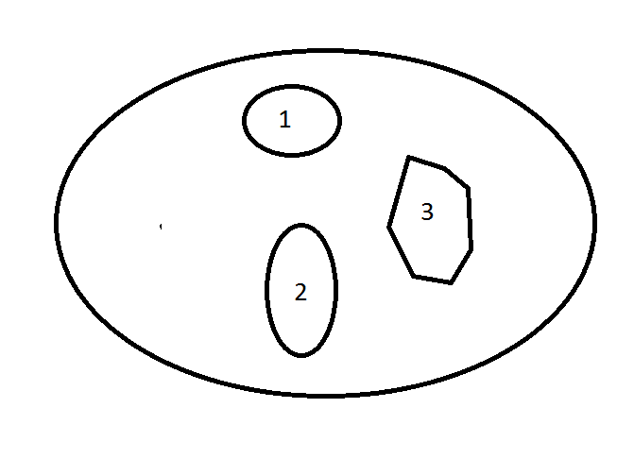

Beam 1

Figure: Body cross section, showing the patient’s tumor (labeled 1), nearby critical tissues (labeled 2), healthy anatomy (labeled 3), and the orientation of Beams 1 and 2

The table below provides relevant parameters regarding the radiation beams, as well as treatment requirements set out by the patient’s doctors.

|  |  |  |  |
| --- | --- | --- | --- |
|  | **Fraction of entry dose impacting different areas** | |  |
| **Area** | **Beam 1** | **Beam 2** | **Restriction on total dosage**  **(in kilorads)** |
| Healthy anatomy | 0.4 | 0.5 | Minimize |
| Critical tissues | 0.3 | 0.1 | ≤ 2.7 |
| Center of tumor | 0.6 | 0.4 | ≥ 6 |

The first column lists the areas of the body that must be considered. The next two columns give the fraction of the radiation dose coming out of each beam that is absorbed by the respective areas. For example, if the dose level out of Beam 1 is 1 kilorad, then 0.4 kilorad will be absorbed by the entire healthy anatomy, 0.3 kilorad will be absorbed by nearby critical tissues, and 0.6 kilorad will be absorbed by the center of the tumor (these do not need to add up to 1). The last column gives restrictions on the total dosage from both beams that affects the respective areas of the body. In particular, the dosage for the healthy anatomy must be as small as possible, the dosage to the critical tissues must not exceed 2.7 kilorads, and the center of the tumor must receive at least 6 kilorads.

1. Formulate a linear programming model to determine a treatment plan for the patient. Clearly state what the decision variables are, along with the objective and constraints, in an algebraic formulation.
2. Use Python/Gurobi to determine the optimal decisions and optimal objective function. State the results in plain language.
3. Now suppose the doctors want to understand the tradeoffs between the objective of minimizing the total dosage delivered to the healthy anatomy and an objective of delivering as much total dosage to the center of the tumor (keeping the <= 2.7 kilorads to the critical issues as a hard constraint). Create the Pareto optimal tradeoff curve for these two objectives and explain it in plain language. Explain how you constructed the curve.